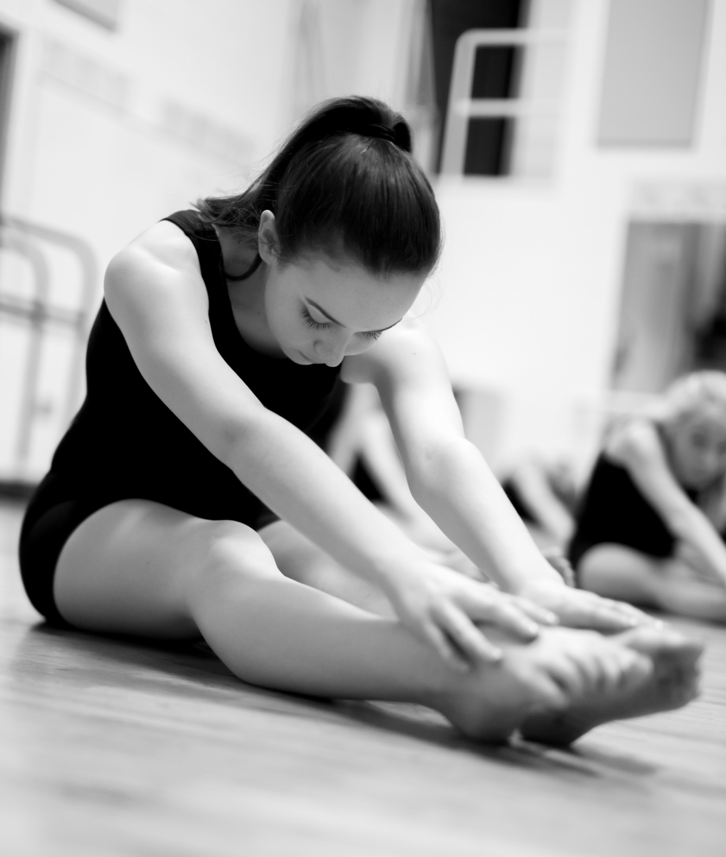Dunsmuir Middle School

Dance Academy

Application Package

**(for new Dance Academy students)**

2025-2026

**Dunsmuir Middle School**

**Dance Academy Application 2025/2026 (for new students)**

Please use the checklist below to ensure that you have completed all of the necessary steps to apply for dance academy.

All documents must be submitted directly to the DMS main office or via email to [danica.anderson@sd62.bc.ca](mailto:danica.anderson@sd62.bc.ca) , no later than Friday, February 28th at 4:00pm.

**Parent Checklist:**

Contact Information (Form A)

Dancer Statement of Intent (Form B)

Community Reference (Form C)

Current Classroom Teacher Reference (Form D)

Online registration Feb.3rd 8:00am - *https://registration.sd62.bc.ca/academy.html*

$268.75 Deposit due online at time of registration

***General Information***

Please note: online registration and the submission of the required application package does not guarantee placement in the Dance Academy. All applications will be reviewed and then official confirmation letters will be emailed out prior to Spring Break.

Placement into the Dance Academy program will be based on the strength of the application package and completion of the online registration.

**How can I find out more about the Dunsmuir Dance Academy?**

* Please visit our website at: www.dunsmuirdanceacademy.weebly.com

* Contact the Dance Academy Program Director, *Danica Anderson*: [danica.anderson@sd62.bc.ca](mailto:danica.anderson@sd62.bc.ca)

**For more information about registration, fees/payment options, and bursaries:**

Contact the Principal of Academies, Wayne Kelly: [wkelly@sd62.bc.ca](mailto:wkelly@sd62.bc.ca)

**DMS Dance Academy** Student Name: *(First and Last)*: ___________________________

**FORM A: Contact Information**

Current Grade: _____

Current School: _______________________________________

Parent/Guardian Name: __________________________________________________

Phone #: ___________________________________

Parent Email: _____________________________________________

STUDENTS: Please fill out the following **based on the past 3 years**.

*Studio Dance Training – include name of studio(s), style(s) of dance, etc.:*

*Any dance-related training (figure skating, gymnastics, cheerleading, musical theatre):*

*Any involvement in team or individual sports, music, and theatre:*

*Any Academic Achievements, Community Involvement, Leadership Experience:*

**DMS Dance Academy** Student Name: *(First and Last)*: ___________________________

**FORM B: Dancer Statement of Intent** *(to be completed by student applicant, not a parent)*

In full sentences, please respond to the following:

**I am applying for placement in Dunsmuir’s Dance Academy because…**

**My personal goals as a dancer…**

**What I really want you to know about me…**

*If you prefer to type your response, please attach it to your application package.*

**DMS Dance Academy** Student Name: *(First and Last)*: ___________________________

**FORM C: Community Reference**

*\*(reference suggestions include: coach, studio dance/music/acting teacher, director, community/volunteer organization director, scout leader, etc.)*

Please note: the community reference may NOT be a member of your family.

**Reference Information:**

Reference Name: ____________________________________________________________________

Contact (email and/or phone): ____________________________________________________________

Relationship to the applicant: ____________________________________________________________

*Signature:* I, ____________________________________________ consider the above named student to be a suitable candidate to be considered for entry into the Dunsmuir Middle School Dance Academy.

*Please check the following areas where applicable (1 being the lowest; 5 being the highest)*

|  |  |  |  |  |  |
| --- | --- | --- | --- | --- | --- |
|  | 1 | 2 | 3 | 4 | 5 |
| Attendance |  |  |  |  |  |
| Work Habits/Effort |  |  |  |  |  |
| Attitude/Behaviour |  |  |  |  |  |
| Listening/Ability to Focus and follow directions |  |  |  |  |  |
| Social Skills (respectful, kind, interactions with others) |  |  |  |  |  |
| Personal Responsibility |  |  |  |  |  |

**Comments or Concerns (*these are very important to me!)*:**

________________________________________________________________________________________________________________________________________________________________________________________________________________________________________________________________________________________________________________________________________________________________________

***Reference must be received at Dunsmuir School no later than February 28th 4:00pm***

If you wish to have your reference remain anonymous, please detach and return to:

c/o Miss Danica Anderson

Dunsmuir Middle School Dance Academy

3341 Painter Road, Victoria, BC V9C 2J1

**OR** Scan & email to: [danica.anderson@sd62.bc.ca](mailto:danica.anderson@sd62.bc.ca)

**DMS Dance Academy** Student Name: *(First and Last)*: ___________________________

**FORM D: Current Classroom Teacher Reference**

Current School: ________________________________

Current Grade: _____

Current Classroom Teacher Name: _________________________________________

Teacher’s Contact email: ________________________________

**Please check the following areas as you see fit (1 being the lowest; 5 being the highest)**

|  |  |  |  |  |  |
| --- | --- | --- | --- | --- | --- |
|  | 1 | 2 | 3 | 4 | 5 |
| Attendance |  |  |  |  |  |
| Work Habits/Effort |  |  |  |  |  |
| Attitude/Behaviour |  |  |  |  |  |
| Listening/Ability to Focus and follow directions |  |  |  |  |  |
| Social Skills (respectful, kind, interactions with others) |  |  |  |  |  |
| Personal Responsibility |  |  |  |  |  |

**Comments/Concerns:** *(*teachers – these comments are really important to me!)*

____________________________________________________________________________________________________________________________________________________________________________________________________________________________________________________________________________________________________________________________________________________________________________________________________________________________________________________________________________________________________________________________________________________________

***Reference must be received at Dunsmuir School no later than February 28th 4:00pm***

Teachers please detach and return this form to:

c/o Danica Anderson

Dunsmuir Middle School Dance Academy

3341 Painter Road, Victoria, BC V9C 2J1

**OR**

Scan & email to: danica.anderson@sd62.bc.ca