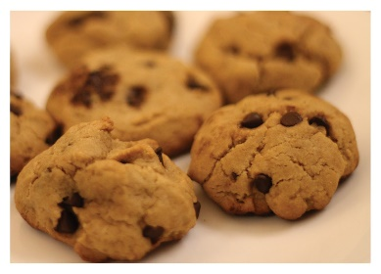***Please Support our***



[This Photo](https://vivebailandovane.blogspot.com/2015/10/hip-hop.html) by Unknown Author is licensed under [CC BY-NC-ND](https://creativecommons.org/licenses/by-nc-nd/3.0/)

***Dunsmuir Hip Hop Club***

**Fundraiser**

**Mom’s Pantry – Frozen Cookie and Muffin Dough!**

**Orders will be accepted until November 4th**

**Go to the following link for ordering ONLINE: https://online.ultimatefundraising.ca/dunsmuirschoolhiphopclub/cookiedough/volunteers/register**

Forms of payment accepted: cash or cheque (payable to SD62)  
Orders will be available to pick-up from Dunsmuir School Dance Studio during the first week of December (detailed pick-up date/time TBA)

*Any questions, please contact Miss. Anderson:* [*danica.anderson@sd62.bc.ca*](mailto:danica.anderson@sd62.bc.ca)